**Storage Account Replication**

Storage account replication is about protecting your data from unplanned events like hardware failures, network outages, and even natural disasters.

How you choose to replicate your data also impacts the service level agreement for storage. Your data is always replicated in the primary data center. You can just expand on that with other options.

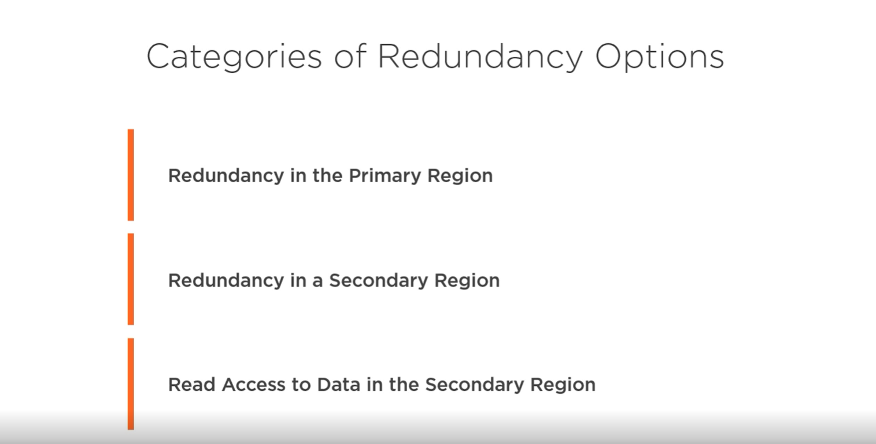There are three categories that group the replication options, redundancy in the primary region, redundancy in a secondary region, and read access to data in the secondary region.

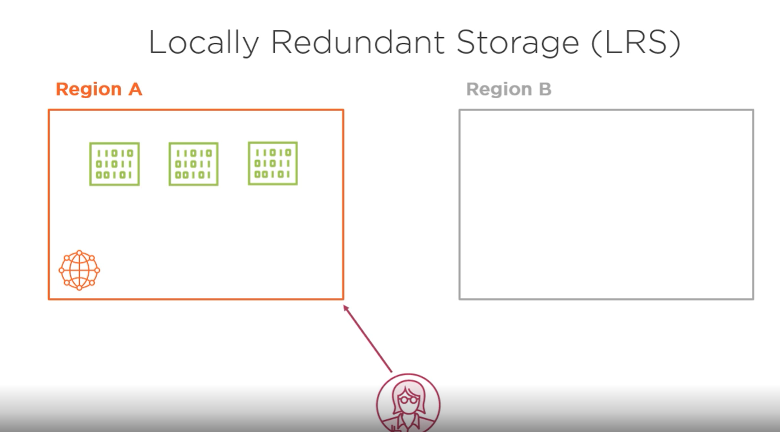

Let's start with the primary region options. Locally redundant storage is the lowest‑cost replication option. Your data is replicated within a collection of racks of storage nodes within a single data center in the region that you choose when you create your storage account. This is called a storage scale unit. Your data is spread across multiple hardware racks, so it's still available when a hardware failure impacts a single rack. **But because all the data is within a single data center, there's always the risk of a data center‑level disaster, like a fire or flooding. To help mitigate the risk, the next storage account type is zone‑redundant storage**.

LRS is a good choice for the following scenarios:

* If your application stores data that can be easily reconstructed if data loss occurs, you may opt for LRS.
* If your application is restricted to replicating data only within a country or region due to data governance requirements, you may opt for LRS. In some cases, the paired regions across which the data is geo-replicated may be in another country or region.

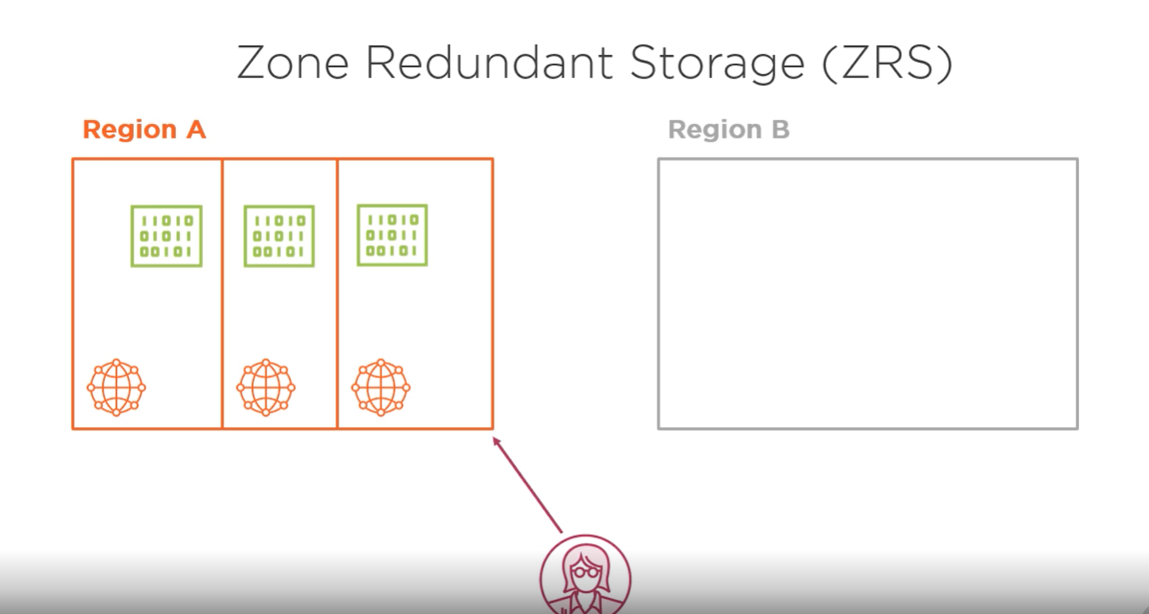

This storage replicates your data across three storage clusters in a single region. Each cluster is physically separate in what's called an availability zone, with its different utilities and networking.

Zone‑redundant storage isn't available in every Azure region, and depending on the service and region, not all storage services may be available. When you create a new storage account and choose a region, you'll be able to see if zone‑redundant storage is available to you. So locally redundant storage and zone‑redundant storage provide redundancy in the primary Azure region your storage account is located within.

* Microsoft recommends using ZRS in the primary region for scenarios that require consistency, durability, and high availability. Also, recommend using ZRS if you want to restrict an application to replicate data only within a country or region because of data governance requirements.
* ZRS provides excellent performance, low latency, and resiliency for your data if it becomes temporarily unavailable. However, ZRS by itself may not protect your data against a regional disaster where multiple zones are permanently affected.

Now let's talk about the options that provide redundancy in a secondary region. There are two options available, **geo‑redundant storage** and **geo‑zone‑redundant storage**.

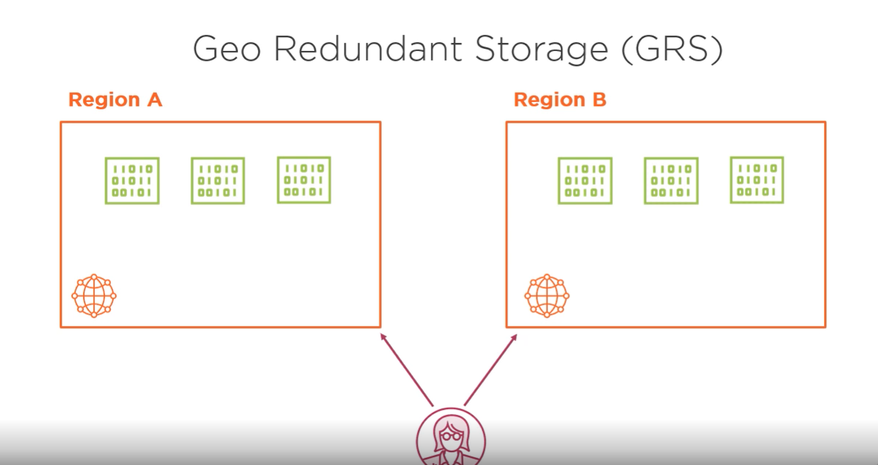

Geo‑redundant storage copies your data three times in the primary region and also copies the data asynchronously to a single location in a secondary region. The data is copied three times in the second data center. It's basically locally redundant storage in two regions. The location of the second region is decided by Microsoft, and you can't change that. But it's selected to be hundreds of miles away from the primary region to prevent data loss in the event of a natural disaster. Paired regions are often within the same country—for example, East US and West US or Canada Central and Canada East.

These are the list of the paired regions corresponding to their Geographical area,

|  |  |
| --- | --- |
| **Geography** | **Paired regions** |
| Asia | East Asia / Southeast Asia |
| Australia | Australia East / Australia Southeast |
| Australia | Australia Central / Australia Central 2 |
| Brazil | Brazil South (1) / South Central US |
| Canada | Canada Central / Canada East |
| China | China North / China East |
| China | China North 2 / China East 2 |
| Europe | North Europe (Ireland) / West Europe (Netherlands) |
| France | France Central / France South |
| Germany | Germany Central / Germany Northeast |
| India | Central India / South India |
| India | West India / South India |
| Japan | Japan East / Japan West |
| Korea | Korea Central / Korea South |
| North America | East US / West US |
| North America | East US 2 / Central US |
| North America | North Central US / South Central US |
| North America | West US 2 / West Central US |
| South Africa | South Africa North / South Africa West |
| UK | UK West / UK South |
| United Arab Emirates | UAE North / UAE Central |
| US Department of Defense | US DoD East / US DoD Central |
| US Government | US Gov Arizona / US Gov Texas |
| US Government | US Gov Iowa / US Gov Virginia |
| US Government | US Gov Virginia / US Gov Texas |

Here are a couple of notes about the region pairs listed in the table:

* West India is paired to South India in one direction only. South India’s region pair is Central India.
* Brazil South is paired (in one direction) with the South Central US region outside its geographic region. This is a unique region, as it’s the only one without a pair in the same geographic region.
* The US Government regions have similarly unusual pairing. The US Gov Iowa’s secondary region is US Gov Virginia; US Gov Virginia’s secondary region is US Gov Texas, and US Gov Texas’ secondary region is US Gov Arizona.

When setting up services like SQL Database Geo-Replication and other services, the Azure Portal will guide you by telling you the “recommended” Azure Region to use as a secondary. This will always be the Azure Region Pair, so you don’t need to memorize the entire list Azure Region Pairs.

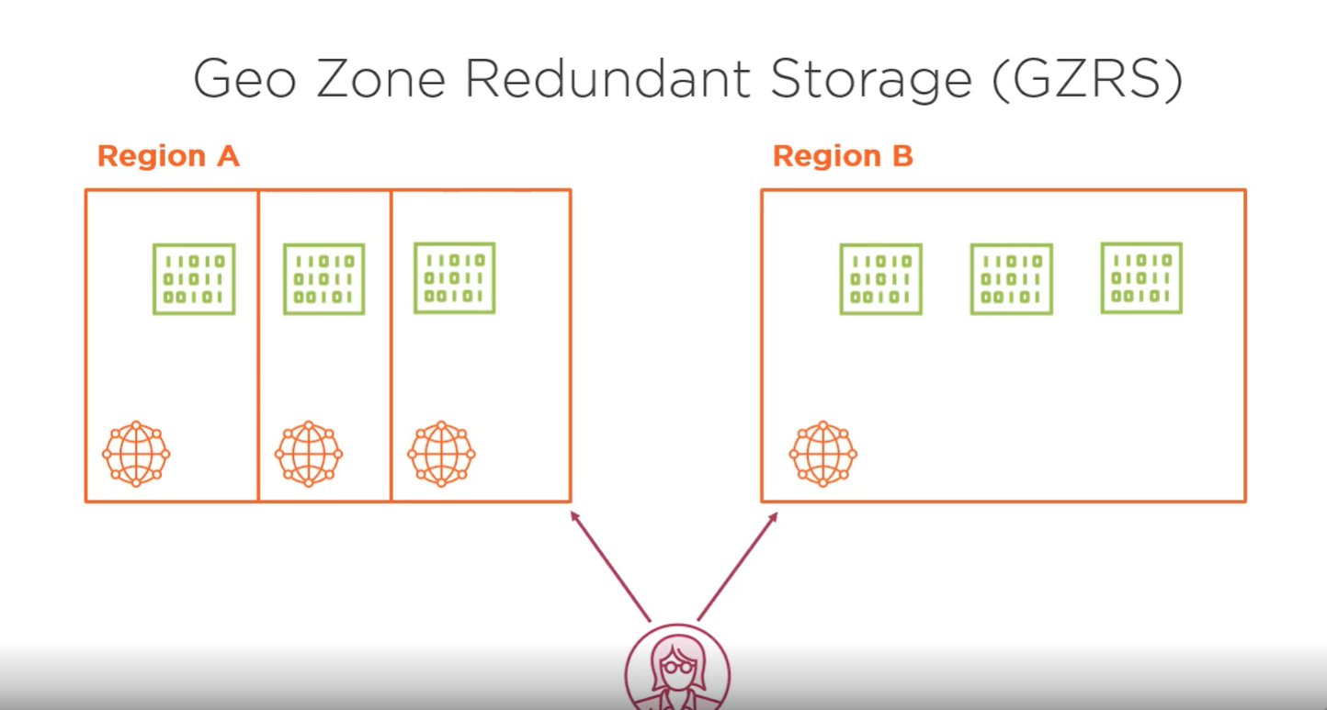

The second option for redundancy in a secondary region is geo‑zone‑redundant storage. This replication option uses zone‑redundant storage in the primary data center and locally redundant storage in a secondary data center. The geo‑zone‑redundant option requires you to use a GPv2 storage account type. **With geo‑redundant and geo‑zone‑redundant storage, the data in the secondary region is only available to be read if you or Microsoft initiates a failover from the primary region to the secondary.**

**You might want to always have the ability for your application to read the data in the secondary region. You might do this so your application automatically fails over to the secondary region without waiting for the service to notice a problem, or you might just want more control over reads for performance reasons.**

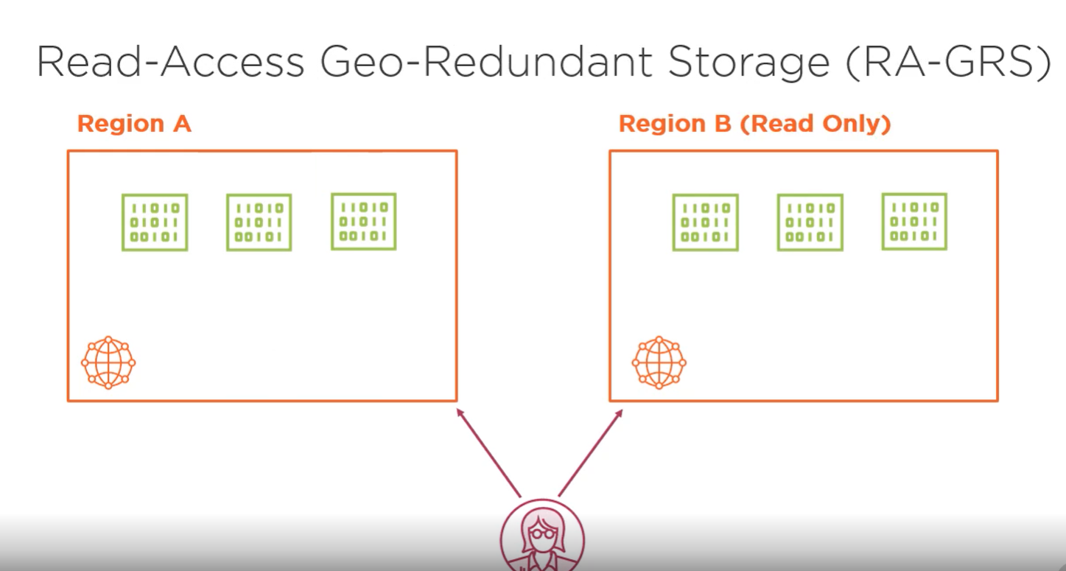

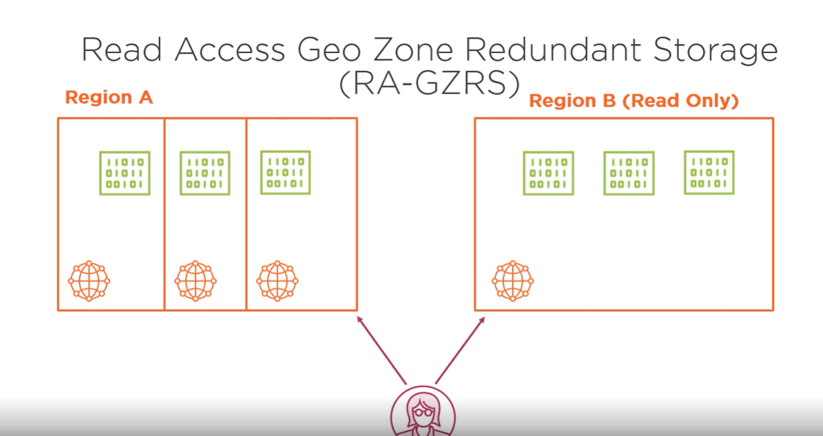

To enable this, there are two other replication options, read‑access geo‑redundant storage, and read‑access geo‑zone‑redundant storage. The two options are similar to the previous versions that we discussed, geo‑redundant, and geo‑zone‑redundant storage. **They just add the ability to always be able to read data from the secondary region.** The replication options available depend on which storage account type you select, the GPv2 type offers the most options.

For the Premium storage account types, Azure Premium file storage currently only supports locally redundant storage, and block blob storage accounts support locally redundant storage, and in some regions, zone‑redundant storage is also available.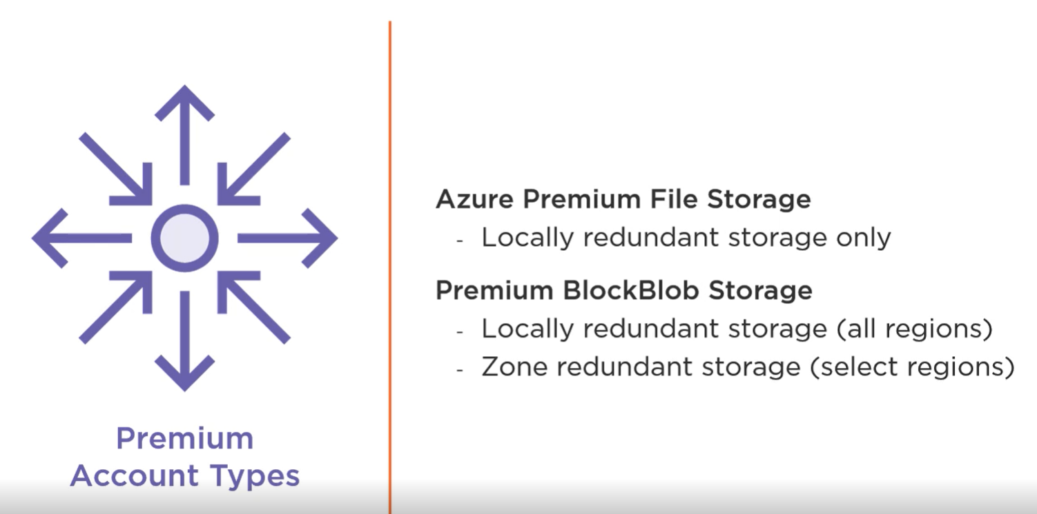

**How to create a storage account and how to configure replication for our data in two different locations.**

From the Azure portal, navigate to the Storage accounts section. Once there, click on Add. Select your subscription and either choose a resource group or create a new one.

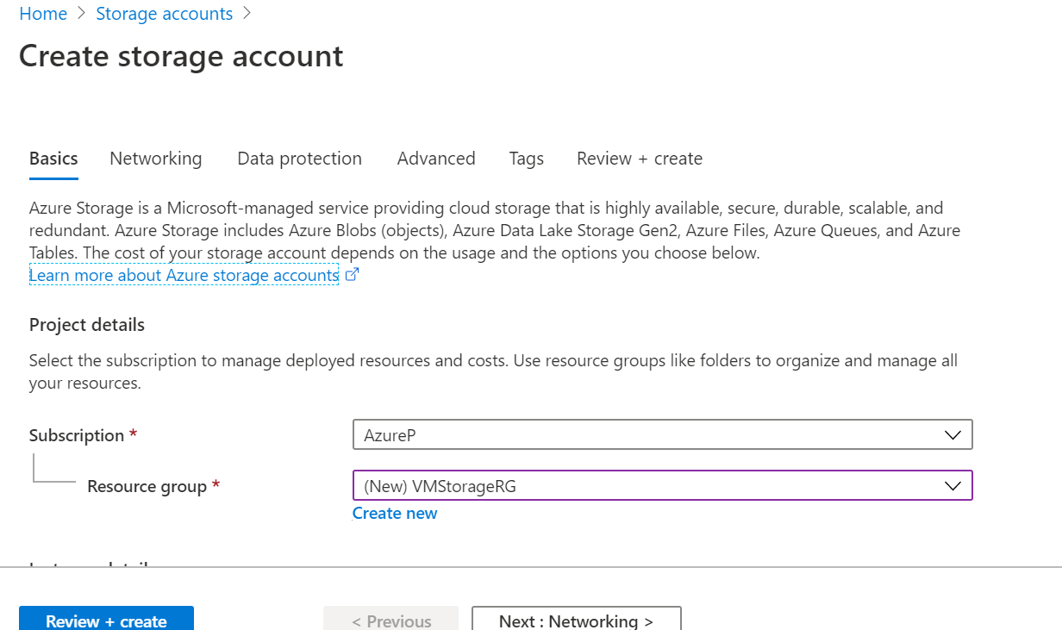

In my case, I will create a new resource group called VMStorageRG. I need to provide a unique name for my storage account. Let's see if 01testing is available. I get the green checkmark, so I'm okay using this name. I'll keep the defaults for the location and performance. For the account kind, simply make sure to select StorageV2 from the list. Now the exciting part, replication options. In this case, I will choose Read‑access‑geo‑redundant‑storage.

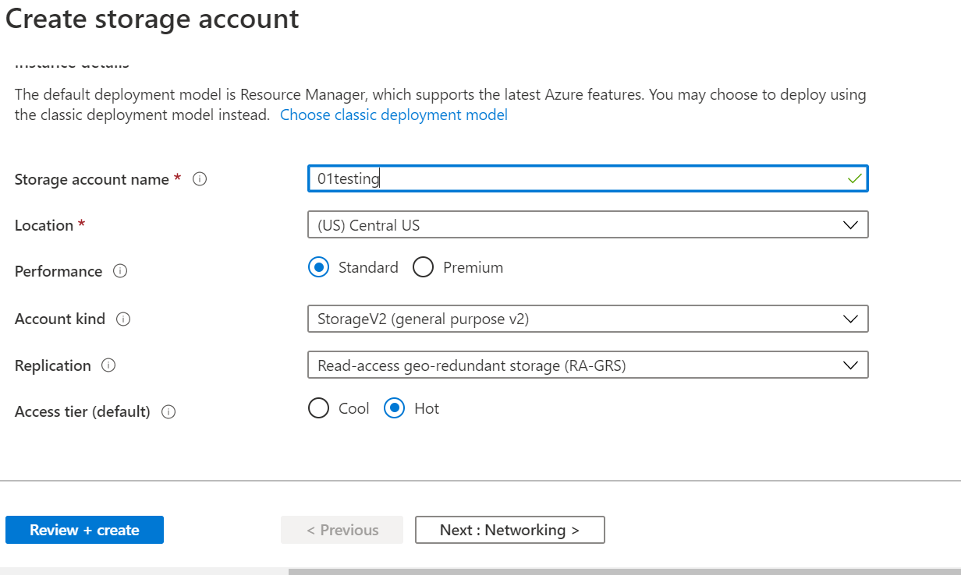Once done, click on Review and Create. Correct anything that would prevent validation of this new storage account and click on Create again.

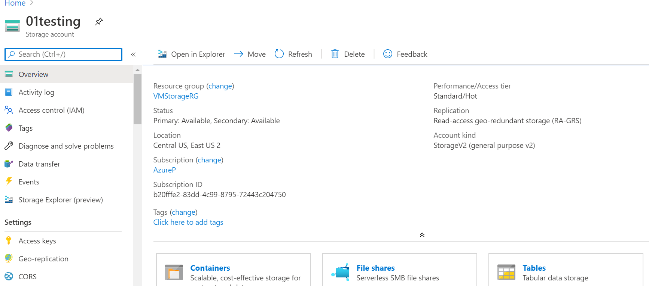

Go to Resource to access our newly created storage account. If we take a quick look at the details within the overview page, we can see the status of the storage account is available and both the primary and the secondary results. Another vital piece of information here is the locations, which, in my case, are the Central US and East US 2.

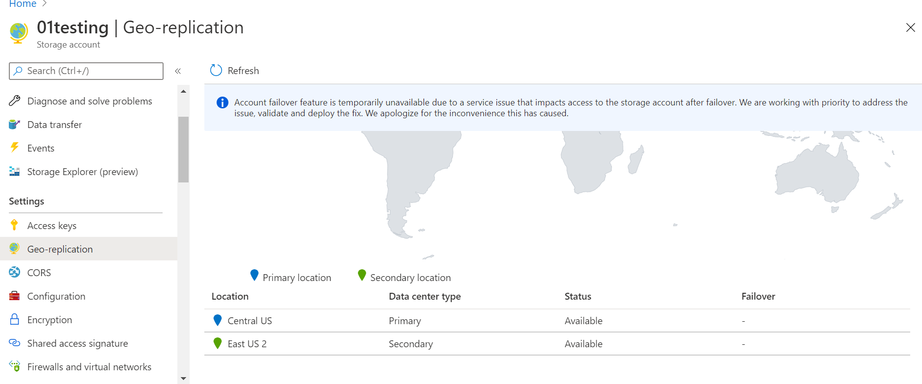

To get a world view of the zones, click on Geo‑replication. **The primary location is Central US, in blue here. The secondary location, East US 2, is represented here in green. The chances that both these locations suffer an outage at the same time are quite small, and your applications can keep running inevitably.**

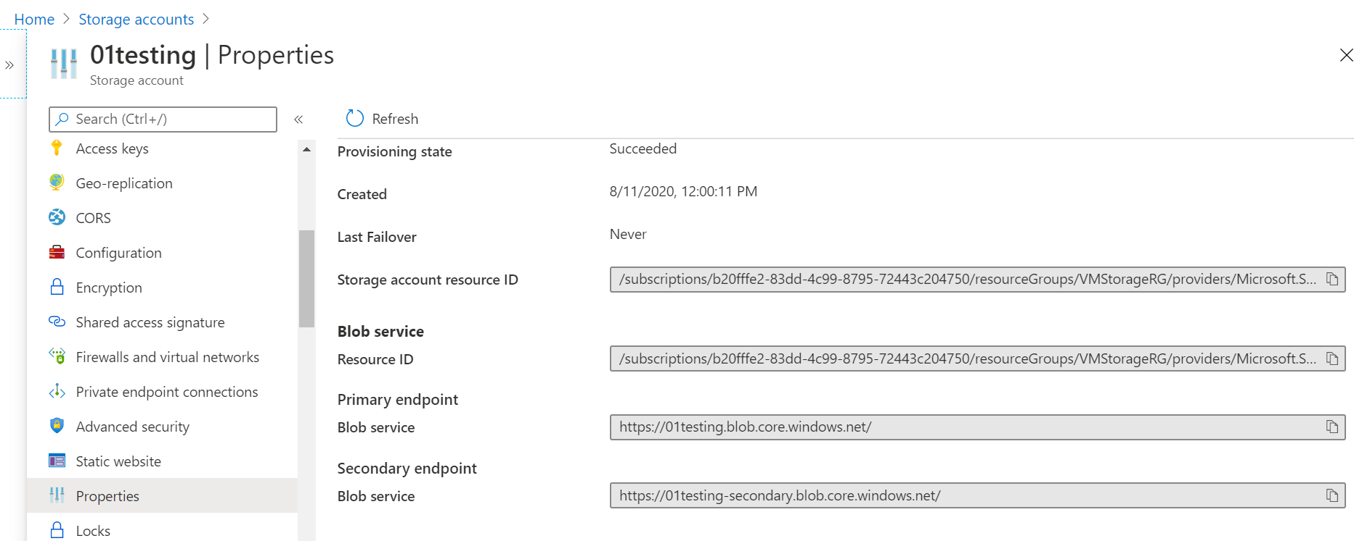

Now let's go to Properties. From here, we can see if we take as an example the **blob service** that the **primary and secondary endpoints are just the same. The only secondary was added**. In the event of an outage in the primary location, Microsoft will take care of switching these DNS entries for you so that the secondary location becomes the primary.

Account failover feature is temporarily unavailable due to a service issue that impacts access to the storage account after failover. Microsoft Azure is working with priority to address the issue, validate and deploy the fix.

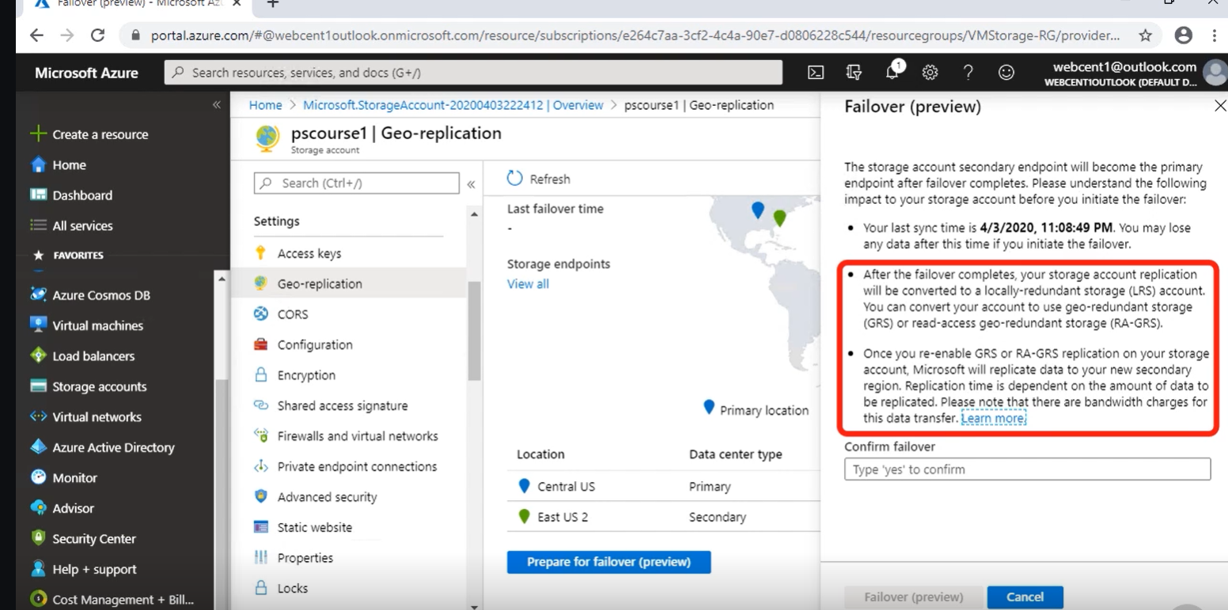

If you want to initiate the failover by yourself, you could use a preview available from the Geo‑replication section. At the bottom of the page, click on Prepare for failover. You can see the last sync time between the two locations. An important warning here states that the storage account replication will be converted to a locally redundant storage account. To enable replication again to another region, you will need to re‑enable GRS or RA‑GRS replication on your storage account.